# Lecture Audio Creator

### Abstract

To bring a next-gen learning experience through Al-driven teaching, we are developing a Lecture Audio Creator system. Our proposed solution uses PDF lecture slides and textbooks to automatically generate engaging, customized lecture audio integrated with a Q&A session. In contrast to current methods, such as mentioned by Rahman and Koka, which do not incorporate these tailored interactions, our approach focuses on a personalized educational experience. By minimizing the amount of time students need to spend researching a topic, this system allows for more efficient study strategies thus improving both learning effectiveness and engagement.

### Research Goals and Problem Statement

The primary challenge this research addresses is the lack of personalized, interactive, and adaptive educational experiences in AI-generated lecture content. For instance, previous studies have focused on creating video content from pre-written speaker notes to make education more accessible [1, 2] but have not addressed the challenge of generating contents interactively with students. To overcome these limitations, we propose a system that generates segmented audio lectures from PDF slides that do not have these pre-written speaker notes, enriched through “human-in-the-loop” interaction by enabling students to ask questions and receive clarifications [4, 5]. This approach builds on the concept of using AI to support personalized learning environments, as demonstrated by virtual teaching assistants like Jill Watson [5] and the evolution of AI applications in education discussed by Roll and Wylie [6].

To support a high-quality learning experience, this project will follow these design requirements:

1. Customization for Different Learning Styles & Generating Engaging Content
2. Adaptive Feedback Mechanism on Confusion Areas
3. RAG: Integration of Supplementary Material, e.g. Textbooks

### Description of the Proposed Work and Expected Outcome

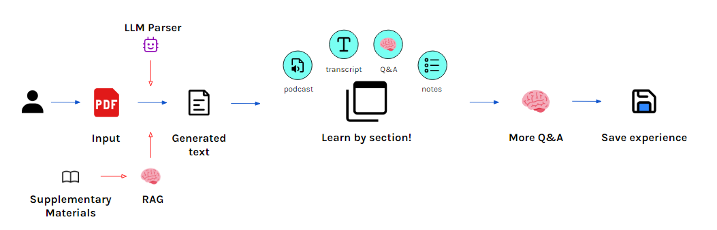

The proposed solution involves building a pipeline that processes the contents of a PDF and generates tailored audio lectures. The pipeline consists of several stages: text extraction, segmentation (into sections), content creation, audio generation and interactive response.

The whole process can be described as (1) PDF and supplementary materials Uploading/Initial Instruction Prompt; (2) Text generation and text-to-speech conversion page by page; (3) Automatic section segmentation; (4) After generation, user is able to take the class and ask question during the lesson.

**Evaluation/Validation Method:**

1. **We propose the concept of 'Key Concept Coverage Recall,' which indicates the extent to which the core concepts are covered in the reconstructed class. This allows us to compare the performance of our agent with other methods.**
2. **We will then invite users to experience our product and provide satisfaction ratings for the class reconstruction. Methods such as A/B testing can be used to evaluate the performance of different approaches and models.**

### Prior Work (How the Research Relates to Prior Work)

AI-generated educational content has advanced with applications such as automated video lecture creation and AI-powered Massive Open Online Courses (MOOCs). They focused on creating video content from recorded in-person lectures and pre-written lecture scripts to automatically generate MOOC videos, making education more accessible and scalable to larger audiences [1, 2]. Rahman and Koka’s work on enhancing lecture video navigation with AI-generated summaries showed the effectiveness of improving learning through more accessible navigation of content [3]. Additionally, frameworks such as AI Teacher Responses in Educational Dialogues demonstrated the benefits of personalized and interactive environments in improving learning outcomes [4]. Our research aims to extend these content creation frameworks, offering a comprehensive tool for a more engaging educational experience tailored to individual student needs.

### References

[1] Patil, S., Zhang, T., Wang, X., and Gonzalez, J. E. AI-powered MOOC Video-Generation. In Proceedings of the 2021 CHI Conference on Human Factors in Computing Systems, pages 1-12, 2021.

[2] Smith, J. and Johnson, M. Automated Video Generation Based on Lecture Content. Journal of Information Systems Education, 31(4):307-318, 2020.

[3] Rahman, A. and Koka, S. Enhancing lecture video navigation with AI-generated summaries. In Proceedings of the 2022 ACM Conference on Learning at Scale, pages 245-256, 2022.

[4] Brown, T. and Davis, R. AI Teacher Responses in Educational Dialogues: A Framework for Personalized Learning. arXiv preprint arXiv:2306.06941, 2023.

[5] Goel, A. K., and Polepeddi, L. Jill Watson: A virtual teaching assistant for online education. Georgia Institute of Technology, 2018.

[6] Roll, I., and Wylie, R. Evolution and revolution in artificial intelligence in education. International Journal of Artificial Intelligence in Education, 26(2):582-599, 2016.